Ilina Jha

Professor Marina Ptukhina

Math 347 – Design Analysis

Policy Impacts on Inflation

# Introduction

Inflation indicates the changes in price levels in an economy over time. Inflation is influenced by multiple factors like actions taken by central bank such as increasing/ decreasing the interest – Monetary Policy, actions taken by central government to control tax policy, unemployment, global economy at the time and other growth objectives.

In this project I wanted to understand the impact of monetary and fiscal policies on inflation across different categories of countries: developed, developing, and underdeveloped. The primary objective for my project was to determine which policy—monetary or fiscal—should be recommended for each country category to achieve the target inflation rate of 2%. The analysis considers the actions taken by central banks for monetary policy and the policies implemented by governments for fiscal policy.

# Method

*Treatment and Design Structure:* In this study, I have a two-way treatment structure (qualitative by qualitative) based on Country and Policy. Where the country is categorized as Developed, Developing and Underdeveloped, the policies are categorized as Monetary and Fiscal. The design structure follows a Completely Randomized Design (CRD). The response variable is inflation that follows a Beta distribution, as Inflation is measured in percentages, so it makes sense to follow Beta Distribution. We could use the WWFD (1) to organize the Treatment, Design Structures to calculate the numerator and denominator degrees of freedom.

# Model

Inflation, our response variable follows a beta distribution which can be denoted by $Y_{ij} \sim Beta(μ_{ij},ϕ)$, where $μ_{ij}$ is the overall mean and $ϕ$ determines the shape of the parameter. For beta distribution we use a logit link $η_{ij} = log(μ_{ij}/ 1- μ_{ij})$ to transform our linear predictor to a scale that is bounded between 0 and 1, aligning with the bounds of the Beta distribution. The linear predictor is $η_{ij} =η_{}+ Country_{i} + Policy_{j}+ Country_{i}*Policy_{j}$, where $η_{}$ is the overall intercept. $Country_{i}$ is the country effect on $i^{th}$ observation and $Policy_{j}$ is the policy effect on the $j^{th}$ observation and $Country_{i}*Policy_{j}$ is the interaction term.

# Analysis

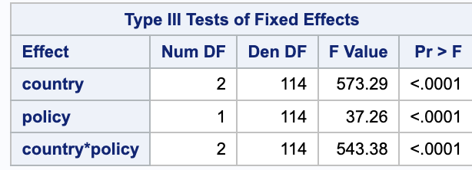

Figure 2

From the type III tests of fixed effects, we can confirm our numerator degrees of freedom and denominator degrees of freedom from the WWFD table. The interaction between country and policy is significant because of lower p value (< .0001) so we are going to look at simple effects and answer questions such as which policy should be recommended at each country level or is there only one policy favored for all three country categories.

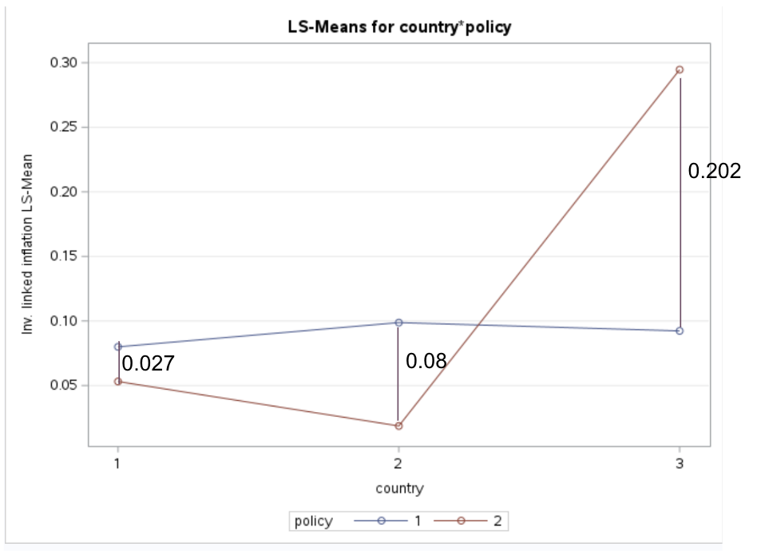

Figure 3

From the Figure 3 above policy 1 is indicated for Monetary Policy and policy 2 is indicated for Fiscal Policy. Country 1 is developed, Country 2 is developing, and Country 3 is undeveloped.

From our above discussion we want to look at a lower response since the targeted inflation rate for developed countries is 2%. In Figure 3, at Country 1 (Developed Country) level Policy 2 (Fiscal Policy would be recommended as lower response is better. Similarly, at Country 2 (Developing Country) level Policy 2 - (Fiscal Policy) would be recommended as lower response is better. But at Country 3 (Underdeveloped Country) we observe a flip in a lower response. So, we would recommend Policy 1 (Monetary Policy).

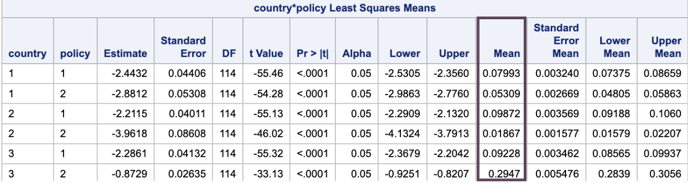

Figure 4

From figure 4, using the mean for each comparison it was interesting to note how the width between the two means at each country level increases going from Developed Country (width: 0.027) to Underdeveloped Country (width: 0.202) as pointed out in figure 3.

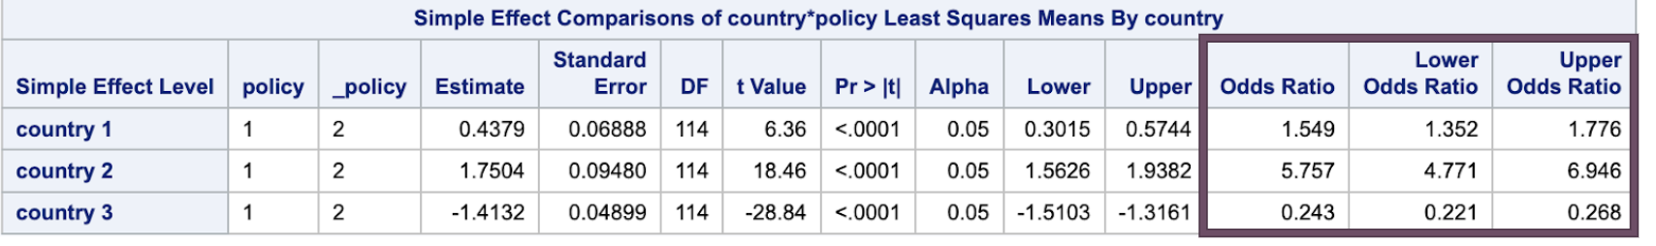

Figure 5

From Figure 5, we draw our final analysis. For Country 1 (Developed), figure 5 indicates that the odds of implementing Policy 1 compared to Policy 2 are 1.549, with statistical significance evidence due to the odds ratio =1 being outside the lower and upper bounds, corroborated by a low p-value. As policy 2 (Fiscal Policy) yields a lower response compared to Policy 1, thus recommending the Fiscal Policy for Developed countries.

Similarly, for Country 2 (Developing), the odds of implementing Policy 1 compared to Policy 2 is 5.757, with significance due to low p-value and odds ratio = 1 being outside the lower and upper bounds. As with Developed countries, Policy 2 (Fiscal Policy) is favored over Policy 1 due to its lower response for Developing countries.

In contrast, for Country 3 (Underdeveloped), the odds of implementing Policy 2 compared to Policy 1 is 4.115, derived by inverting the odds ratio as it was less than 1. This finding, supported by a confidence interval (3.731, 4.524) which is statistically significant because of OR = 1 being outside the lower and upper bound confirmed by the low p value (<.001), suggests that Policy 2 (Monetary Policy) is recommended for Underdeveloped countries since it yields a lower response compared to Policy 1.

# Conclusion

Overall, Fiscal Policy is recommended for Developed and Developing countries to achieve the target inflation rate of 2%. While monetary policy is recommended for Underdeveloped Countries. However, it is important to remember that the recommendation is based on simulated data. Target inflation is achieved with combinations of these two policies which means we are recommending the countries to focus on either of the policies. It is also important to note other factors such as unemployment rate, economic environment at the time and other growth objectives influence Inflation as well that should be kept in mind for recommendation.

# 

# Appendix

1. Table 1 - What Would Fisher Do Table

|  |  |  |  |  |  |
| --- | --- | --- | --- | --- | --- |
| Design | df | Treatment | df | Combined | df |
|  |  | Country | 3-1=2 | Country | 3-1=2 |
|  |  | Policy | 2-1=1 | Policy | 2-1=1 |
|  |  | Country*Policy | 2*1 =2 | Country*Policy | 2*1=2 |
| e. u | 120-1 =119 |  |  | e.u|Country, Policy, Country*Policy | 120-2-1-2 -1 =114 |
| Total | 120-1 =119 | Total | 120-1=119 | Total | 120-1=119 |

1. Figure 2 - Type III of fixed effects code:

proc glimmix data=inflation method=quadrature;

class country policy;

model inflation=country|policy/d=beta;

run;

1. Figure 3 – LS means for country*policy code:

proc glimmix data=inflation method=quadrature;

class country policy;

model inflation=country|policy/d=beta;

lsmeans policy*country /plot=meanplot(sliceby=policy ilink join);

run;

1. Figure 4 – country*policy least square means code:

proc glimmix data=inflation method=quadrature;

class country policy;

model inflation=country|policy/d=beta;

lsmeans policy*country /plot=meanplot(sliceby=policy ilink join);

lsmeans policy*country /ilink slicediff=(policy country) oddsratio cl;

run;

1. Figure 5 – Simple Effect comparison for country*policy least square means by country code:

proc glimmix data=inflation method=quadrature;

class country policy;

model inflation=country|policy/d=beta;

lsmeans policy*country /plot=meanplot(sliceby=policy ilink join);

lsmeans policy*country /ilink slicediff=(policy country) oddsratio cl;

run;

# References:

1. Messeri, E. (2023, September 4). *Why the 2% inflation target?*. Michigan Journal of Economics. (<https://sites.lsa.umich.edu/mje/2023/09/04/why-the-2-inflation-target/#:~:text=This%20meant%20that%20costs%20only,and%20an%20increase%20in%20prices>.)
2. Hayes, A. (n.d.). *Fiscal policy vs. monetary policy: Pros and cons*. Investopedia. (<https://www.investopedia.com/articles/investing/050615/fiscal-vs-monetary-policy-pros-cons.asp>)
3. Segal, T. (n.d.). *Monetary policy vs. fiscal policy: What’s the difference?* Investopedia. )<https://www.investopedia.com/ask/answers/100314/whats-difference-between-monetary-policy-and-fiscal-policy.asp#:~:text=Monetary%20and%20fiscal%20policy%20are%20different%20tools%20used%20to%20influence,is%20the%20responsibility%20of%20governments>.)
4. Peters, R., Adewopo, J., Yoshida, N., & Tatulli, R. (2024, April 30). World Bank Open Data. (<https://data.worldbank.org/>)
5. Mankiw, N. G. (2020). *Principles of Macroeconomics*, Measuring a Nation’s Income.